|  |  |
| --- | --- |
|  | **Qatar University**  **College of Engineering**  **Department of Computer Science and Engineering** |

Operating Systems-(CMPS 450)

**Task: Project Phase 1**

*Fall 2024*

**Project Group Members:**

Marwan Hashish ID:201701546

Abdulla Jamali ID: 202104080

Nasser Aljufairi ID: 202005009

Murshed Al-Muhannadi ID: 201706102

**Instructor**: ***Eng.Heba Dawoud***

|  |  |  |
| --- | --- | --- |
| **student name** | **Student part in the Project** | **participation percentage** |
| Marwan Hashish |  |  |
| Abdulla Jamali |  |  |
| Nasser Aljufairi |  |  |
| Murshed Al-Muhannadi |  |  |

**Task 1: Setup Server side (VM1)**

**-Create users on the server (client 1, client2)**

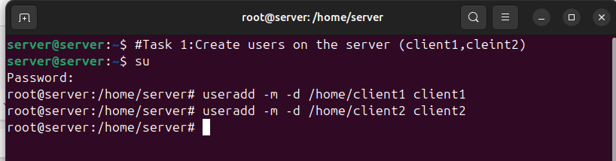-Setting passwords for client1 & client2

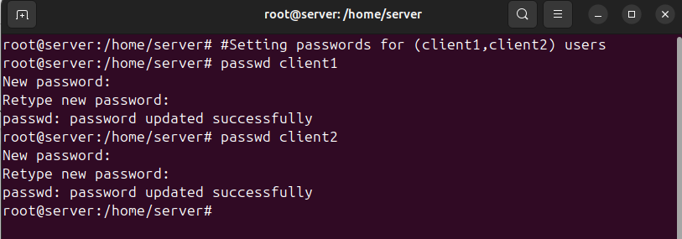-Checking that users are created (client1, client2):



**-Install and enable SHHD**

-Checking if SSH is installed  
-The command to install SSH if it’s not installed: $ sudo apt install openssh-server

But it was already installed so no need for this step.

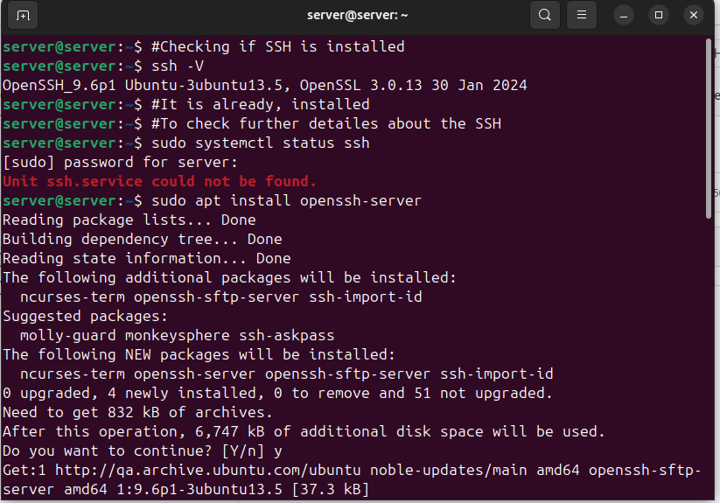-Check if SFTP is working

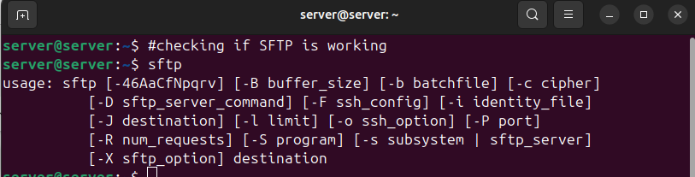

**Task 2 : Configuration**

To Get the IP of the server we did:

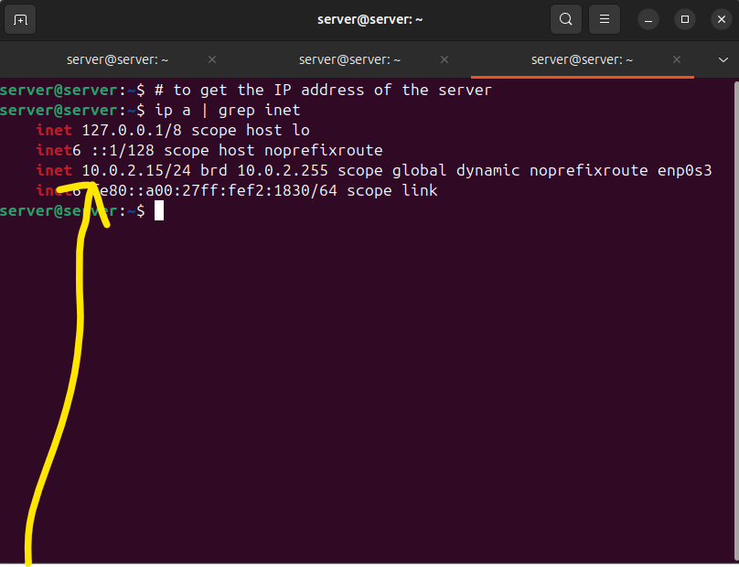

Accessing the server from client 1 using SSH and the ip address of the server we just retrieved:

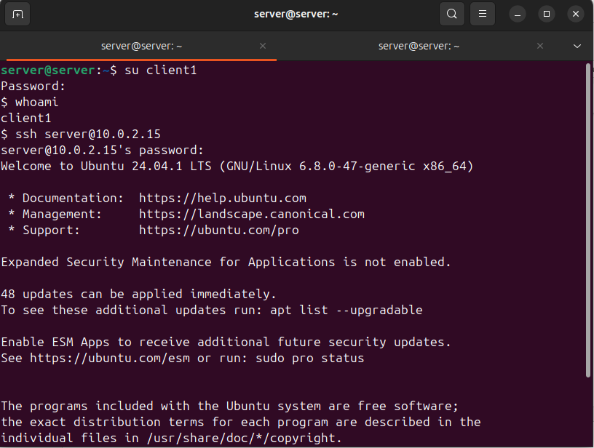

We managed to access the server using SSH (remotely) by client1 user:

-We deduce that SSH is enabled successfully for client 1, we now will do the same for client2:

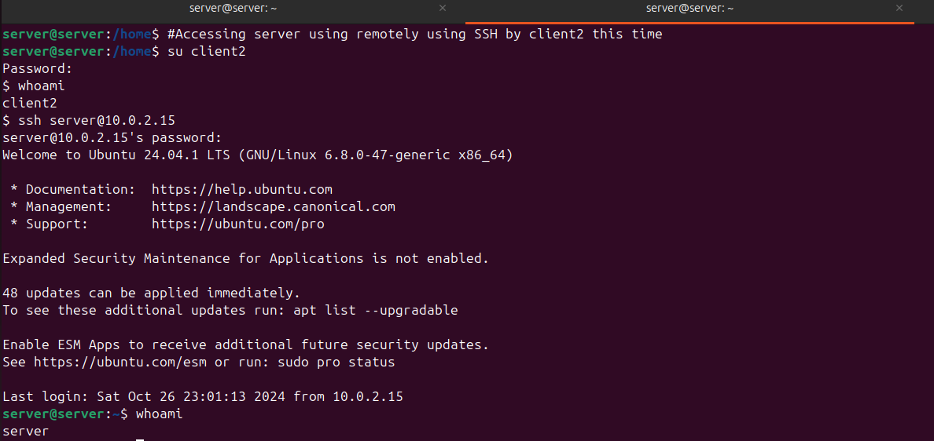

-We deduce that SSH is enabled successfully for client 2

-Mostly the configuration of SSH is done however:

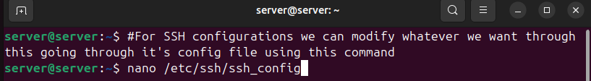

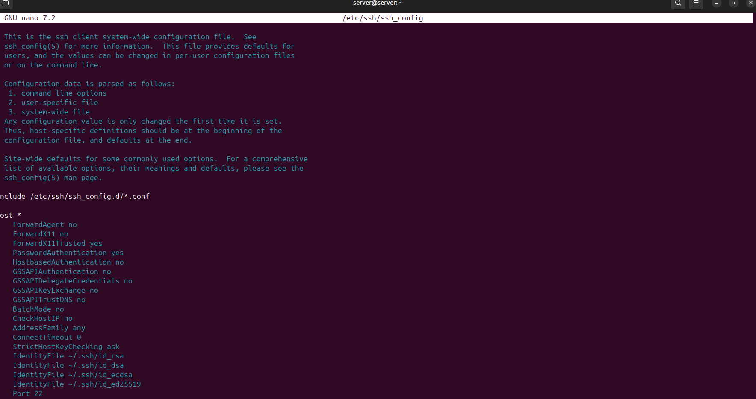

-We can enable or disable based on our needs using: sudo nano /etc/ssh/ssh_config.

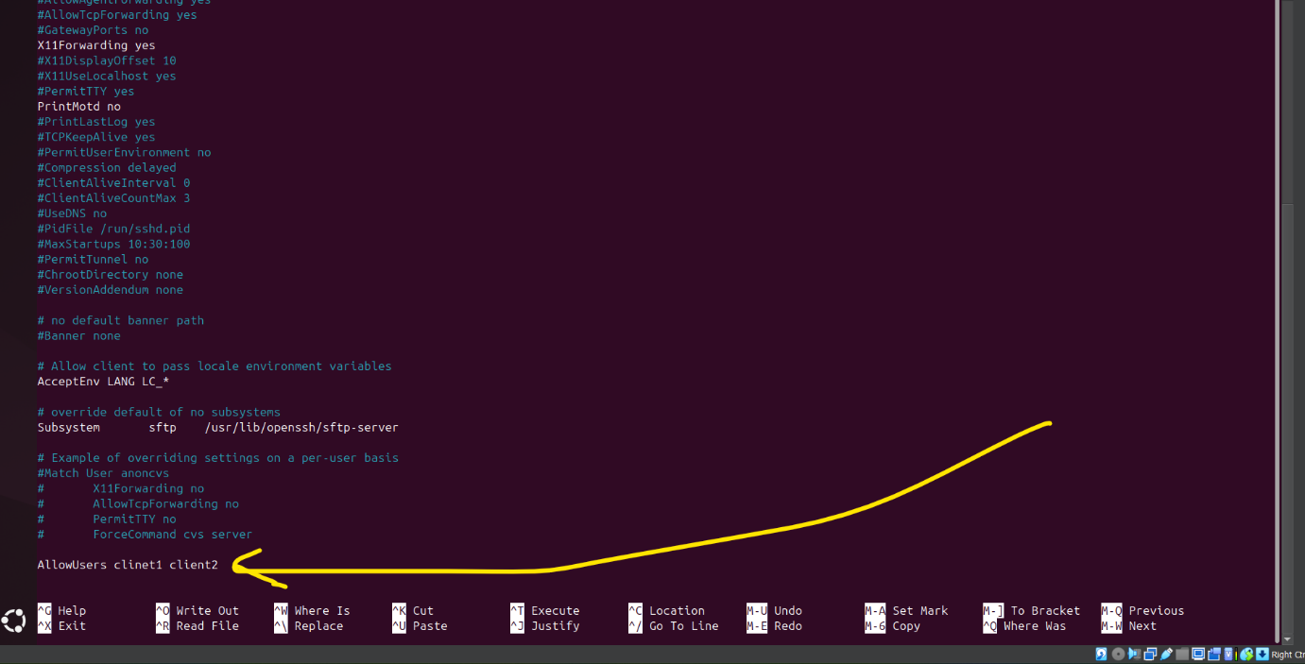

-We add this option for it to only allow the users: client1, client2

-Checking the SCP is working

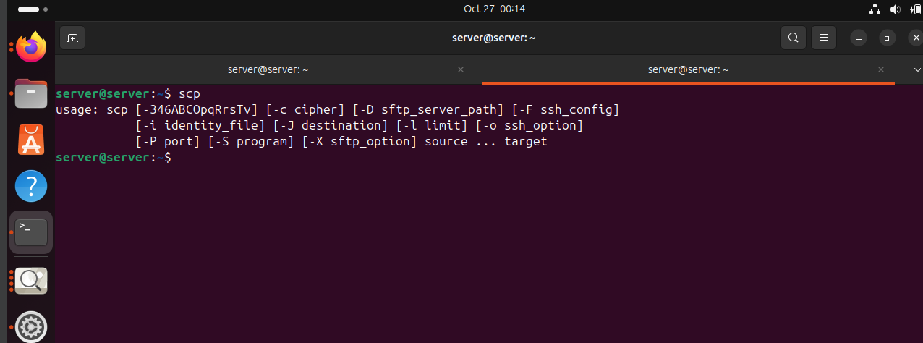

**Task 3: Shell Scripting**

Network.sh: purpose is testing connectivity from server to clients. (using pin)

#!/bin/bash

# Function to install network tools if they are not already installed

install_network_tools() {

# Checking if ping and traceroute commands are available

if ! command -v ping &> /dev/null || ! command -v traceroute &> /dev/null; then

echo "🚀 Installing necessary network tools... Please wait!"

# Installing network tools (ping, traceroute)

sudo apt update && sudo apt install -y iputils-ping traceroute

echo "🎉 Network tools installed successfully! 🚀 Ready to check connectivity."

else

echo "✅ Network tools already installed and ready!"

fi

}

# Function to log message with date and time format

log_message() {

local message=$1

# Getting the current date and time with nanoseconds for uniqueness

local timestamp=$(date "+%Y-%m-%d %H:%M:%S:%N")

# Adding a unique identifier with hostname and process ID

local unique_id=$(hostname)_$$

echo "$timestamp [$unique_id] - $message" | tee -a network.log

}

# Function to check connectivity by pinging the target IP with a retry mechanism

check_connectivity() {

local target_ip=$1

local retries=3

local delay=2

for ((i=1; i<=retries; i++)); do

log_message "Attempting to ping $target_ip... Attempt $i"

if ping -c 1 -W 5 "$target_ip" &> /dev/null; then

log_message "Connectivity with $target_ip is ok."

return 0

else

log_message "Attempt $i failed for $target_ip. Retrying in $((delay * i)) seconds..."

sleep $((delay * i))

fi

done

log_message "Failed to reach $target_ip after $retries attempts. Running traceroute..."

run_traceroute "$target_ip"

}

# Function to run traceroute if ping fails and log output

run_traceroute() {

local target_ip=$1

log_message "Running traceroute for $target_ip..."

{

echo "Routing Table:"

route -n

echo "Hostname: $(hostname)"

echo "Testing DNS resolution:"

nslookup google.com

echo "Tracing route to Google:"

traceroute google.com

echo "Pinging Google for verification:"

ping -c 3 google.com

} | tee -a network.log

# Reboot the machine if connectivity check fails

log_message "Rebooting machine due to connectivity failure."

sudo reboot

}

# Function to generate a custom summary report at the end

summarize_results() {

echo "📊 Summary Report 📊" | tee -a network.log

echo "Total Checks Performed: $total_checks" | tee -a network.log

echo "Successful Connections: $successful_checks" | tee -a network.log

echo "Failed Connections: $failed_checks" | tee -a network.log

}

# Function to detect OS type for compatibility message

detect_os_type() {

if [[ "$OSTYPE" == "linux-gnu"* ]]; then

log_message "Detected Linux OS."

elif [[ "$OSTYPE" == "darwin"* ]]; then

log_message "Detected macOS. Traceroute may differ."

else

log_message "Unknown OS type. Please verify compatibility."

fi

}

# Main script execution

main() {

detect_os_type

install_network_tools

# Initialize counters for a unique summary report

total_checks=0

successful_checks=0

failed_checks=0

# Check if IPs are provided as arguments

if [ $# -lt 1 ]; then

exit_with_code 99 "Error: No IPs provided. Exiting with custom code 99."

fi

# Loop through each IP argument and test connectivity

for target_ip in "$@"; do

total_checks=$((total_checks + 1))

if check_connectivity "$target_ip"; then

successful_checks=$((successful_checks + 1))

else

failed_checks=$((failed_checks + 1))

fi

done

# Call the summarize_results function at the end

summarize_results

}

# Execute the main function with all command-line arguments passed to the script

main "$@"

**Traceroute.sh script**

run_traceroute() {

local target_ip=$1

log_message "Running traceroute for $target_ip..."

{

echo "Routing Table:"

route -n

echo "Hostname: $(hostname)"

echo "Testing DNS resolution:"

nslookup google.com

echo "Tracing route to Google:"

traceroute google.com

echo "Pinging Google for verification:"

ping -c 3 google.com

} | tee -a network.log

log_message "Rebooting machine due to connectivity failure."

sudo reboot

}